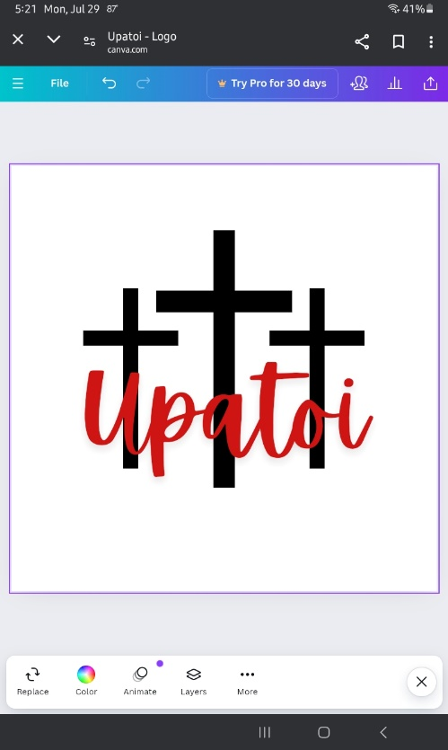

Upatoi Community Church

## 13730 Macon Road

## Upatoi, Georgia 31829

# Phone: 706-561-0433

UpatoiCommunityChurch@gmail.com

Job Title: Pastor

Reports To: SPRC

Position Status: Full-Time

Pay: Total package $35,000 - $40,000, depending on qualifications

Church Size: 124 members with an average attendance of 50

**Upatoi Community Church**

Upatoi Community Church is an independent church nestled in the Georgia Pines off Highway 80 in Upatoi, Muscogee County. We have a loving and friendly church family and enjoy fellowship with each other and our visitors. There is a great spirit here among our people. Our church understands it’s not all about us and that’s why there’s so much involvement in local mission works beyond our community.

Our current sanctuary is 43 years old, but our spirit is 162 years old. Our pianist and choir are amazing for such a small church. We are a traditional church and believe the Bible is the infallible, divinely inspired word of God. Our mission is to find a pastor who will lead and guide us in regrowing and strengthening our congregation especially in the young adult age group and those families with children. A pastor who will bring fresh new church mission and ministry ideas to attract new members, and preach the word of God and the transformative power of the Holy Spirit. Our foremost goal and prayer is to see Upatoi become a vibrant, growing, and spirit-filled congregation of disciples who seek to shine the light of Christ to the world.

The pastor should be willing and able to fulfill the following expectations, goals, and responsibilities:

* Believe that the Bible is the infallible, divinely, inspired word of God.
* Be a committed believer and follower of Jesus Christ as Lord and Savior.
* Be responsible for sermon preparation and delivery, and assist with worship planning.
* Preach scripturally sound sermons.
* Be strongly rooted in Wesleyan theology and the importance of Methodist traditions.
* Facilitate and encourage opportunities for spiritual growth, discipleship, and evangelistic outreach in the community.
* Visit with homebound or nursing home congregants, and those in the hospital.
* Be available to the members of the church for counsel and baptism.
* Perform the ecclesial acts of marriage and burial.
* Have a heart for pastoral care and the ability to provide compassionate/empathetic support to congregation members in time of need.
* Help individual parishioners identify and utilize their gifts within the ministry.
* Devise and implement fresh, new ministries within the church to attract younger people and those with children.
* Lead and teach Bible studies.
* Perform administrative duties such as overseeing the day-to-day operations of the church and working with the Administrative Council in making decisions about the church’s direction, activities, and priorities.
* Encourages unity within the body of Christ and will be the mediator of handling any possible disputes.
* Involvement in the local community and church activities.

If interested in this position, please request an application at UpatoiCommunityChurch@gmail.com.